

S.PREETHAM CHANDRAN

CH.SC.U4CSE24139

Week – 3 Date - 03/01/2026
Design and Analysis of Algorithm(23CSE211)

Merge Sort

Code:
#include <stdio.h>
void merge(int arr[], int l, int m, int r) { int n1 = m - l + 1;
int n2 = r - m; int L[n1], R[n2];
for (int i = 0; i < n1; i++) L[i] = arr[l + i]; for (int j = 0; j < n2; j++) R[j] = arr[m + 1 + j]; int i = 0, j = 0, k = l;
while (i < n1 && j < n2) {
if (L[i] <= R[j]) arr[k++] = L[i++]; else arr[k++] = R[j++];
}
while (i < n1) arr[k++] = L[i++]; while (j < n2) arr[k++] = R[j++];
}
void mergeSort(int arr[], int l, int r) { if (l < r) {
int m = l + (r - l) / 2; mergeSort(arr, l, m); mergeSort(arr, m + 1, r); merge(arr, l, m, r);
}
}
int main() {
int n; printf("CH.SC.U4CSE24139\n");
printf("Enter number of elements: "); scanf("%d", &n);
int arr[n];
printf("Enter the elements:");
for (int i = 0; i < n; i++) scanf("%d", &arr[i]); mergeSort(arr, 0, n - 1);
printf("Sorted array: ");
for (int i = 0; i < n; i++) printf("%d ", arr[i]); printf("\n");
return 0;
}

Output:
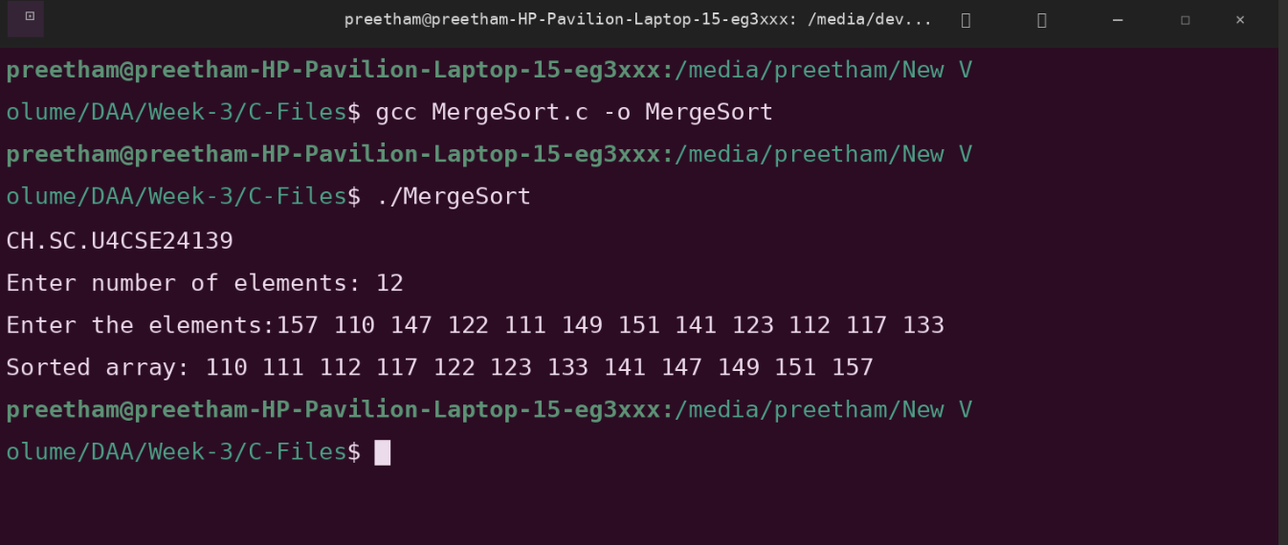

Space Complexity: O(n log n)
Justification: The algorithm recursively divides the array into halves, which takes log n levels of division. At each level, it performs a linear merge process requiring n operations, resulting in a consistent n x log n performance.

Time Complexity: O(n)
Justification: Merge Sort requires an auxiliary array to temporarily hold elements during the merge process. This additional memory is proportional to the size of the input array.

Quick Sort

Code:
#include <stdio.h>
void swap(int* a, int* b) { int t = *a;
*a = *b;
*b = t;
}
int partition(int arr[], int low, int high) { int pivot = arr[high];
int i = (low - 1);
for (int j = low; j <= high - 1; j++) { if (arr[j] < pivot) {
i++;
swap(&arr[i], &arr[j]);
}
}
swap(&arr[i + 1], &arr[high]); return (i + 1);
}
void quickSort(int arr[], int low, int high) { if (low < high) {
int pi = partition(arr, low, high); quickSort(arr, low, pi - 1); quickSort(arr, pi + 1, high);
}
}
int main() {
int n;
printf("Enter number of elements: "); scanf("%d", &n); printf("CH.SC.U4CSE24139\n");
int arr[n];
printf("Enter the elements:");
for (int i = 0; i < n; i++) scanf("%d", &arr[i]); quickSort(arr, 0, n - 1);
printf("Sorted array: ");
for (int i = 0; i < n; i++) printf("%d ", arr[i]); printf("\n");
return 0;
}

Output:
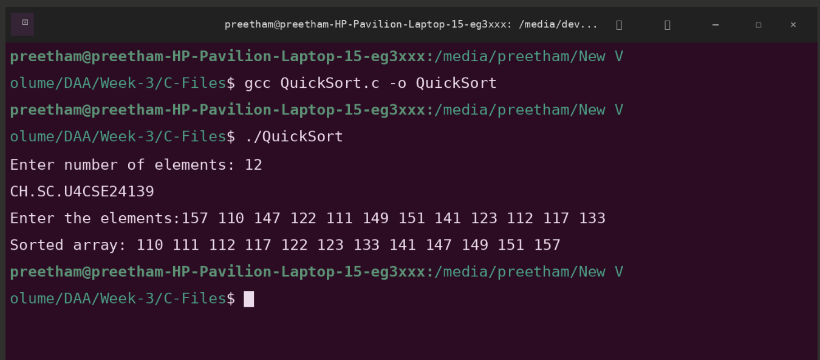

Space Complexity: O(n2)
Justification: This occurs when the pivot consistently picks the smallest or largest element (e.g., on a sorted array). This results in highly unbalanced partitions where one side has 0 elements and the other has n-1, leading to n recursive levels with O(n) work each.

Time Complexity: O(n)
Justification: In the worst-case scenario of an unbalanced partition, the recursion stack depth increases from the ideal log n to n. Each recursive call stays on the stack until it finishes, requiring memory proportional to the number of elements.

